# Project Report

Clean Tech: Transforming Waste Management with Transfer Learning

# INTRODUCTION

## 1.1 Project Overview

The growing volume of improperly disposed waste poses serious environmental and health risks. Effective waste segregation at the source is a critical step in promoting sustainability and improving recycling efficiency. However, manual sorting is often inconsistent, time-consuming, and prone to error. To address this issue, our project Clean Tech: Transforming Waste Management with Transfer Learning leverages deep learning and computer vision to automate waste classification. By using a pre-trained VGG16 model with transfer learning, the system accurately classifies waste images into categories such as recyclable, organic, and hazardous. Users interact with a simple web interface built using HTML, CSS, and JavaScript, while a Flask backend handles image preprocessing and model inference. This solution empowers users to dispose of waste correctly, reduces the burden on recycling facilities, and supports cleaner, smarter cities.

## 1.2 Purpose

The purpose of this system is to automate the classification of waste using deep learning, helping users identify the correct waste category (recyclable, organic, or hazardous) through an image upload. This promotes proper disposal habits, reduces environmental impact, and supports efficient waste management using AI-powered technology.

# 2. IDEATION PHASE

## 2.1 Problem Statement

Improper waste segregation is a major challenge in urban and rural areas, leading to environmental pollution, health hazards, and inefficient recycling. Traditional methods of sorting waste are manual, time-consuming, and often inaccurate. There is a need for an intelligent, automated solution that can assist users in correctly identifying and categorizing waste types to promote cleaner, safer, and more sustainable waste management practices interpretation. To overcome these challenges, there is a growing need for a smart, automated system that can assist individuals in identifying and classifying waste accurately. Leveraging deep learning techniques and transfer learning models can provide an efficient and scalable solution to classify waste images into categories such as recyclable, organic, or hazardous. This approach can improve awareness, encourage responsible disposal habits, and enhance the overall efficiency of waste management infrastructure.

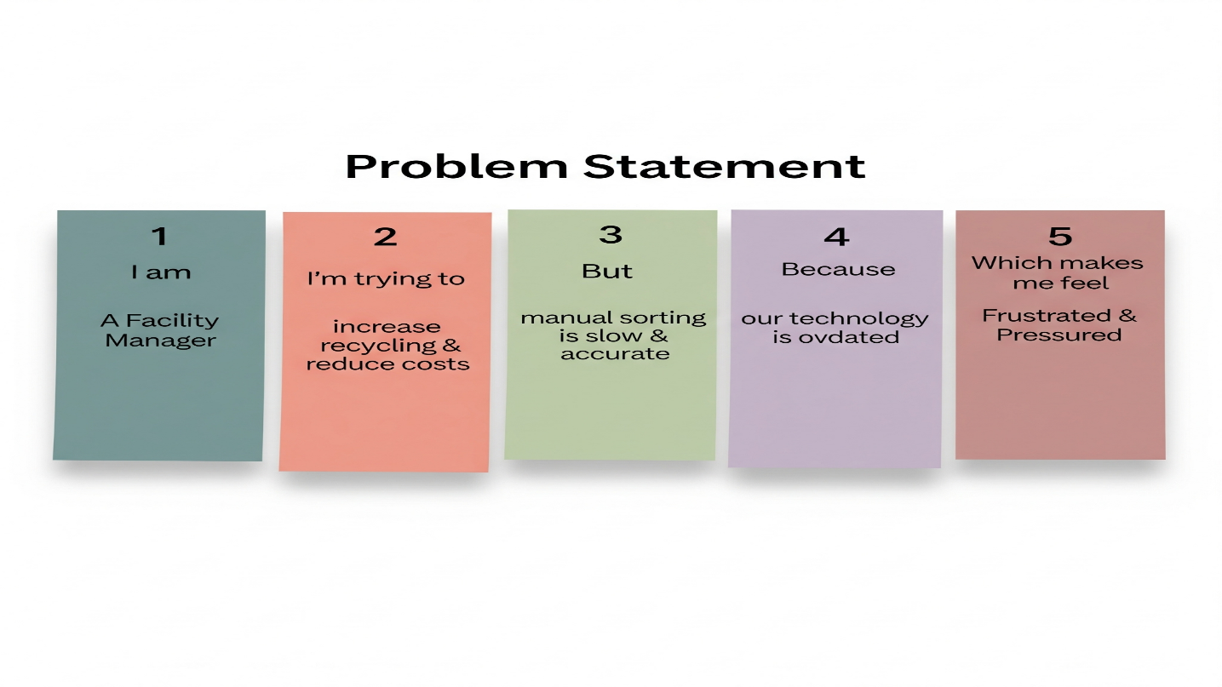

|  |  |  |  |  |  |
| --- | --- | --- | --- | --- | --- |
| **Problem Statement (PS)** | **I am (Customer)** | **I’m trying to** | **But** | **Because** | **Which makes me feel** |
| PS-1 | A Waste Facility Manager in India | Increase recycling & reduce costs | Manual sorting is slow, inaccurate, and contaminates materials. | Our technology is too old for modern, complex waste. | Frustrated & Pressured |
| PS-2 | A Municipal Director | Adopt innovative technology for our city | New AI systems seem too expensive and complex to implement. | The required investment is high, and my team lacks the skills. | Sceptical & Hesitant |
| PS-3 | A Recycling Business Owner | Source a consistent supply of pure, recyclable material | The material I purchase from the facility is often contaminated | The facility's manual sorting process cannot guarantee purity. | Worried about my supply chain and business viability. |

## 2.2 Empathy Map Canvas

In the face of overflowing landfills and inefficient sorting, today's waste management leaders feel the pain of high operational costs and the struggle to meet environmental regulations. While they hear experts discussing cleantech and see competitors adopting AI, they feel worried about the high costs and complexity, making them sceptical of the investment. This leads them to say the current system is adequate while they privately research new options and ask for pilot programs. Our cleantech solution, utilizing transfer learning, directly addresses this conflict by providing an affordable path to their ultimate gains: it automates sorting to save money, increases the purity of recycled materials to meet compliance with ease, and creates a more efficient and profitable facility

. 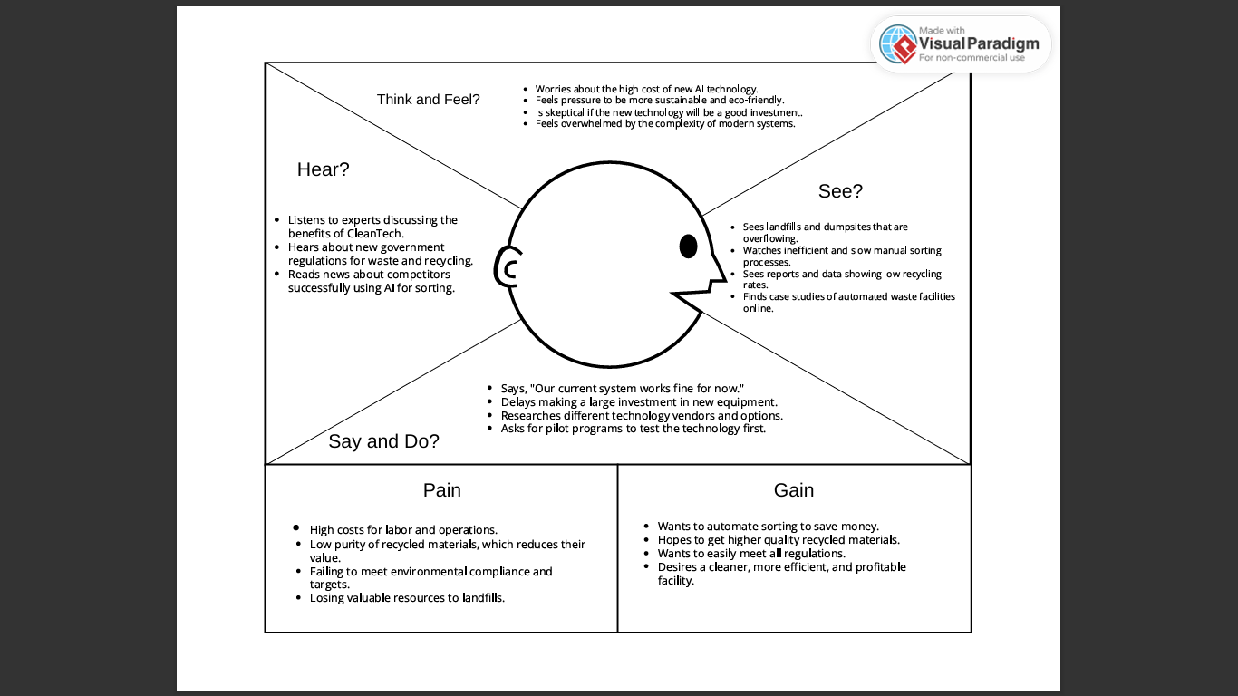

## 2.3 Brainstorming

Brainstorming provides a free and open environment that encourages everyone within a team to participate in the creative thinking process that leads to problem solving. Prioritizing volume over value, out-of-the-box ideas are welcome and built upon, and all participants are encouraged to collaborate, helping each other develop a rich amount of creative solutions.

**Step-1: Team Gathering, Collaboration and Select the Problem Statement**

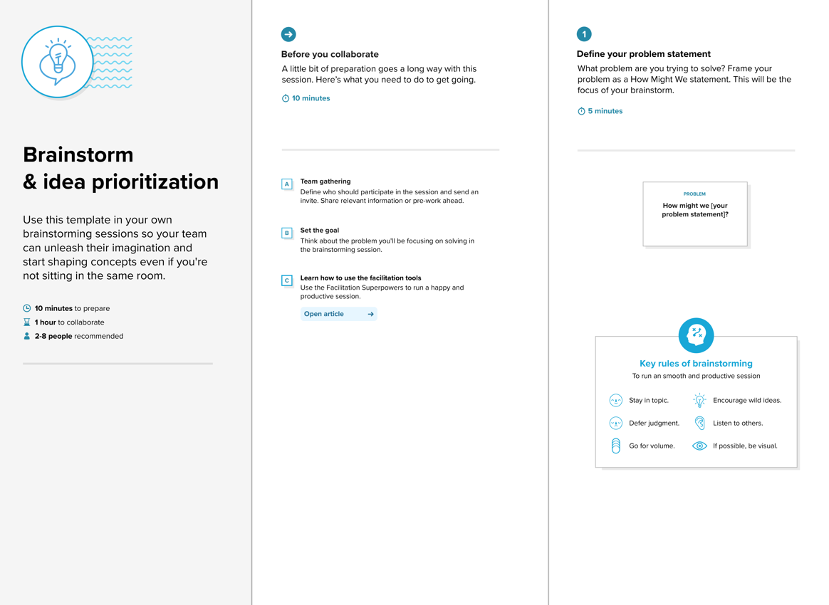

**Step-2: Brainstorm, Idea Listing and Grouping**

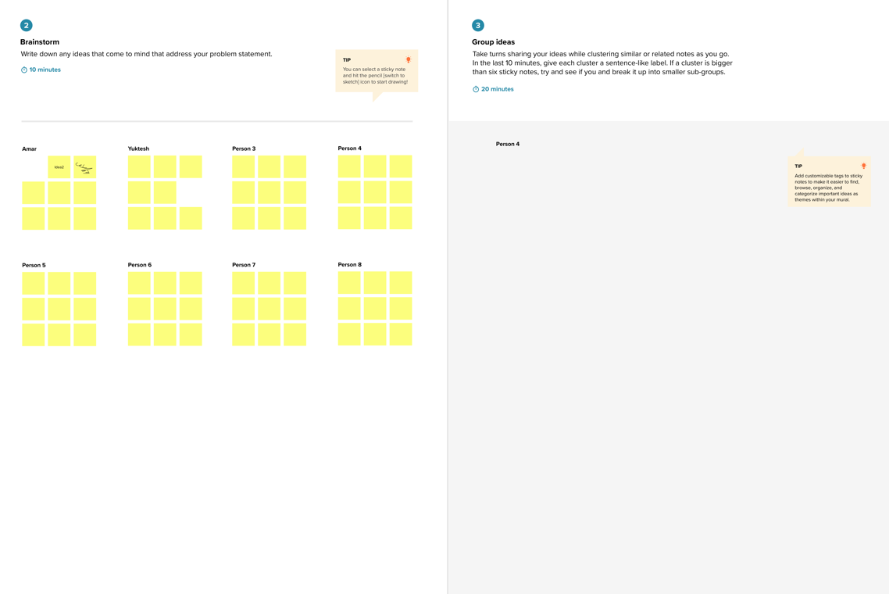

**Step-3: Idea Prioritization**

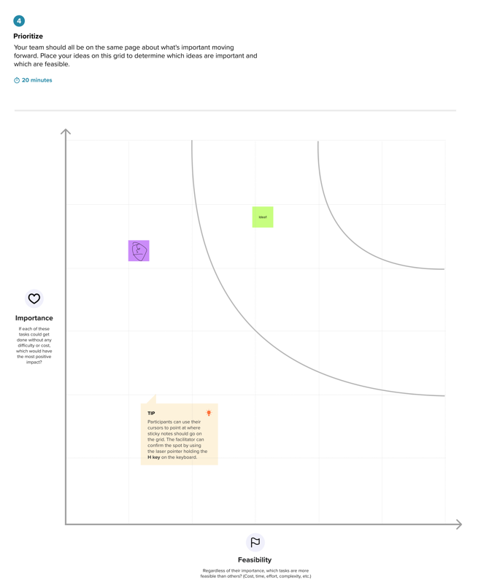

# 3. REQUIREMENT ANALYSIS

## 3.1 Customer Journey Map

The Waste Management Optimization Journey Map clearly illustrates a facility leader's experience with our CleanTech sorting solution. It traces every step, from integrating thesystem and feeding in data, through its daily AI-powered operations, toreceivingperformance reports and actionable insights**.** This map helps us spot what works well, like saving on labour and getting purer recycled materials, and what could be smoother, such as initial setup. By understanding these points, we can continuously improve the system, ensuring it delivers maximum efficiency, profitability, and satisfaction for your operations.

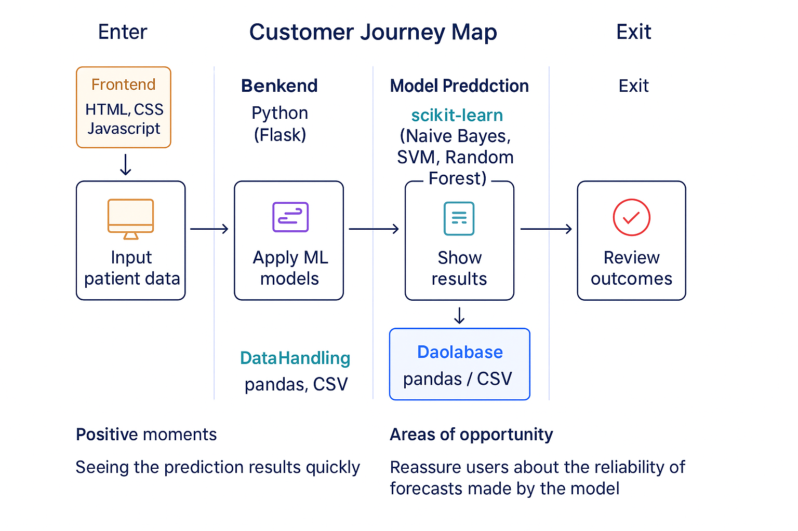

## 3.2 Solution Requirement

The system allows users to upload waste images through a simple web interface. These images are preprocessed and passed to a VGG16 deep learning model, which classifies the waste into categories such as recyclable, organic, or hazardous. Results are displayed instantly on the same interface. The system runs locally using Flask, ensuring fast performance and data privacy. It is designed to be scalable, portable, and easy to maintain.

**Functional Requirements:**

The following are the functional requirements of the proposed solution.

|  |  |  |
| --- | --- | --- |
| **FR No.** | **Functional Requirement (Epic)** | **Sub Requirement (Story / Sub-Task)** |
| FR-1 | Image Input Interface | Allow users to upload an image of a waste item (e.g., JPG, PNG). Provide form validation and clear visual feedback for the upload process. |
| FR-2 | Model Prediction | Use the trained **DL model** to process the image and predict the waste category. Return prediction output as "Recyclable," "Biodegradable," or "Trash." |
| FR-3 | Result Page Generation | Display the prediction result on a clear, dedicated page. Show the user's uploaded image alongside the predicted category. |
| FR-4 | Prediction Output | Display the final predicted waste category in a prominent format. Optionally, include a confidence score or a brief description of the category. |
| FR-5 | User History Dashboard | Registered users can view a log of their past submissions. The dashboard should show the image, the date of upload, and the prediction result for each entry. |
| FR-6 | Model Information | Provide a page describing the model architecture (e.g., VGG16), the dataset used for training, and its accuracy for transparency. |

**Non-functional Requirements:**

|  |  |  |
| --- | --- | --- |
| **FR No.** | **Non-Functional Requirement** | **Description** |
| NFR-1 | **Usability** | The interface should be simple and intuitive, allowing a non-technical user to easily upload an image and understand the result. |
| NFR-2 | **Security** | All user credentials and personal data (if a user system is implemented) must be securely processed and stored. Uploaded images should be handled privately. |
| NFR-3 | **Reliability** | The model should consistently deliver correct classifications for waste types it was trained on, with no unexpected failures. |
| NFR-4 | **Performance** | The prediction must be generated and displayed to the user within 2–3 seconds of submitting the image. |
| NFR-5 | **Availability** | The system should be accessible 24/7 with minimal downtime, allowing users to classify waste whenever needed. |
| NFR-6 | **Scalability** | Should support a growing number of users and concurrent classification requests without a significant drop in performance. |

## 3.3 Data Flow Diagram

This data flow diagram illustrates a complete user interaction cycle for an AI-powered application. The process begins when a user uploads an image via the web application's frontend. The front end then sends the image within an HTTP request to the backend server. The backend server preprocesses this image and sends it to a Deep Learning (DL) model, which in turn returns a prediction result. This result is sent back to the front end through an HTTP response, allowing the result page to be displayed to the user. As an optional final step, the backend server can log the prediction into a database**.**

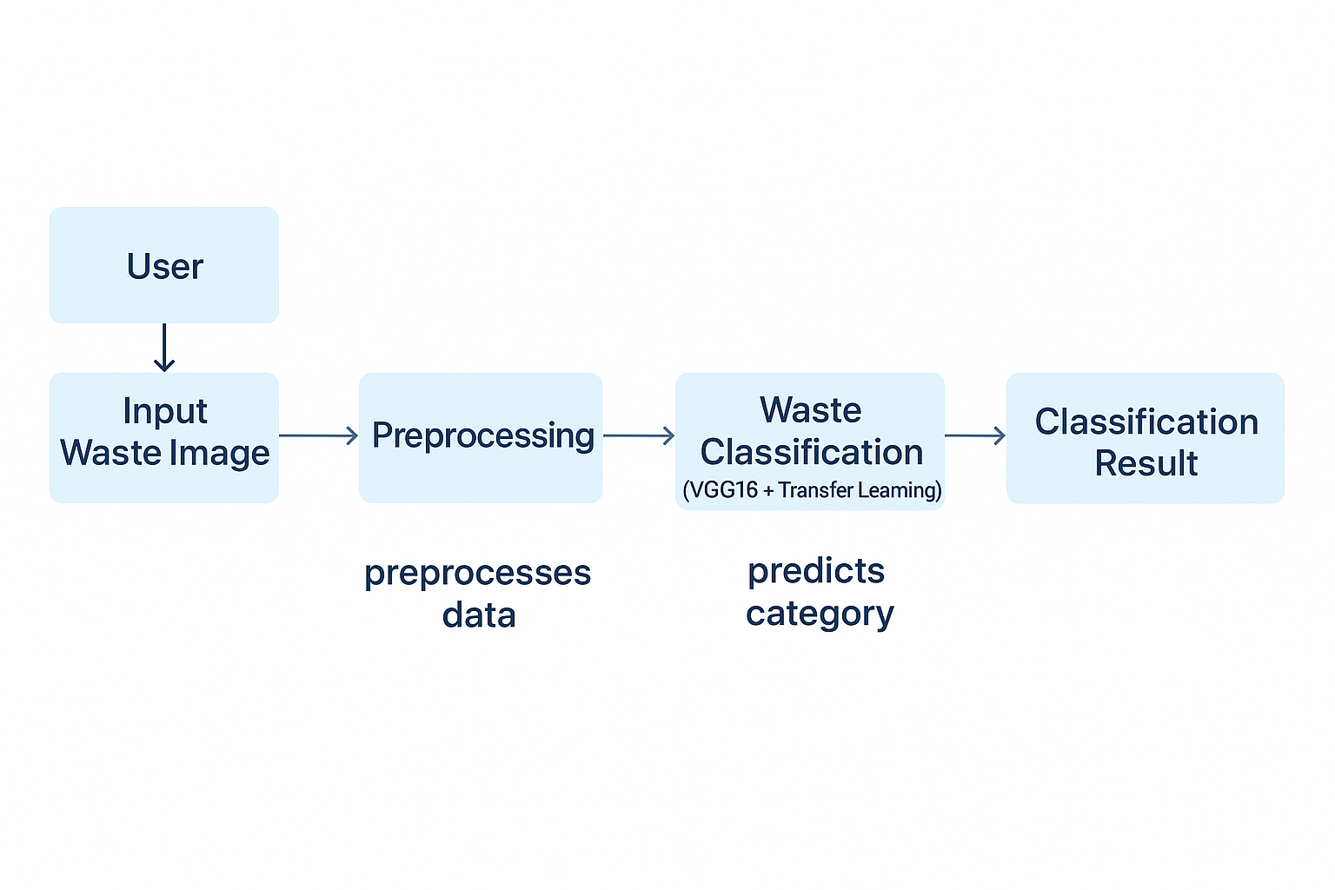

**User Stories**

User stories break down the Cleantech project into small, manageable tasks from the perspective of each user. They help our team focus on building features that provide real value, such as a live dashboard for the Facility Manager, downloadable reports for the Municipal Director, and hardware alerts for the Maintenance Technician. By addressing these specific needs, we ensure the final system is practical, user-focused, and successfully solves the intended challenges in waste management.

| **User Type** | **Functional Requirement (Epic)** | **User Story Number** | **User Story / Task** | **Acceptance criteria** | **Priority** | **Release** |
| --- | --- | --- | --- | --- | --- | --- |
| Facility Manager | Real-time Monitoring | USN-1 | As a Facility Manager, I want to view a live dashboard of the sorting process so that I can monitor operational efficiency. | Dashboard displays key metrics like items sorted per minute, purity rates, and system uptime. | High | Sprint-1 |
| System | Waste Classification | USN-2 | As the system, I want to automatically classify waste materials from the camera feed to enable automated sorting. | The model classifies common materials (e.g., PET, cardboard) with >95% accuracy and sends results to the control system. | High | Sprint-2 |
| Maintenance Technician | System Health Alerts | USN-3 | As a Maintenance Technician, I want to receive an immediate alert if a camera or robotic arm reports a fault to minimize downtime. | An email/SMS alert is sent to a designated contact within 2 minutes of a critical hardware error. | High | Sprint-2 |
| Facility Manager | Performance Analytics | USN-4 | As a Facility Manager, I want to view historical performance trends so that I can identify areas for improvement. | The dashboard allows viewing and comparing recycling rates and costs over daily, weekly, and monthly periods. | Medium | Sprint-1 |
| Municipal Director | Report Download | USN-5 | As a Municipal Director, I want to download a summary performance report so that I can track ROI and compliance. | A report (PDF/DOCX) with key metrics can be downloaded successfully. | Medium | Sprint-3 |
| AI Engineer | Model Management | USN-6 | As an AI Engineer, I want to upload a new dataset to retrain the model so that I can improve its accuracy over time | System provides an interface to upload a labeled dataset and initiate a retraining job. | Medium | Sprint-4 |

## 3.4 Technology Stack

**Technical Architecture:**

The Deliverable shall include the architectural diagram as below and the information as per the Components & Technologies & Application Characteristics

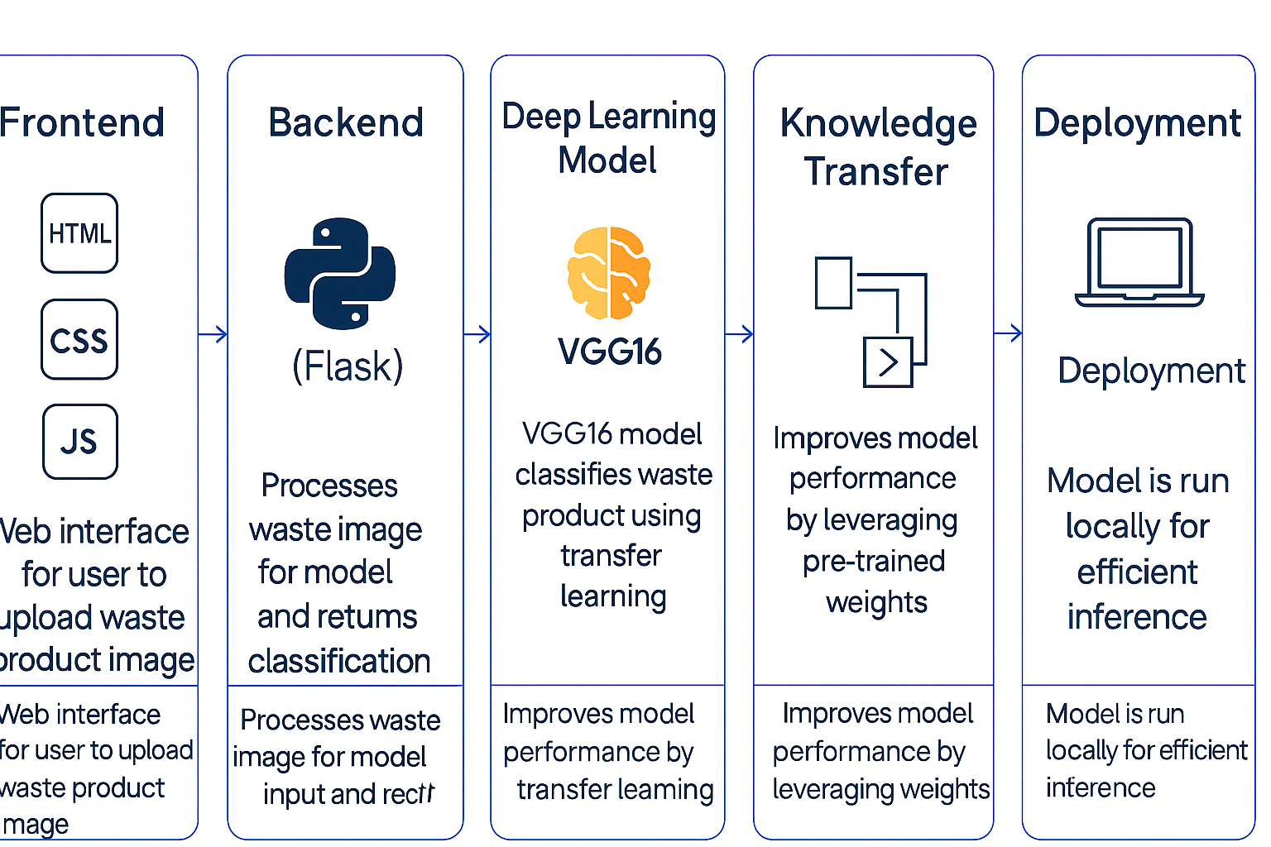

**Components & Technologies:**

|  |  |  |  |
| --- | --- | --- | --- |
| **S.No** | **Component** | **Description** | **Technology** |
|  | User Interface | Web interface for clinicians to input data and view predictions | HTML, CSS, JavaScript |
|  | Application Logic-1 | Data preprocessing and handling missing/categorical values | Python (pandas, NumPy) |
|  | Application Logic-2 | Model training, prediction, and evaluation | Python (scikit-learn) |
|  | Application Logic-3 | Flask-based integration to link frontend and backend | Python (Flask) |
|  | File Storage | Store model files and datasets locally or in GitHub repo | Local Filesystem |
|  | Machine Learning Model | Predicts whether a patient has liver cirrhosis | Naive Bayes, SVM, Random Forest,Logistic regression, |
|  | Infrastructure (Server / Cloud) | Application runs locally using Flask; can be extended to cloud | Local (Flask server) |

**Application Characteristics:**

| **S.No** | **Characteristics** | **Description** | **Technology** |
| --- | --- | --- | --- |
|  | Open-Source Frameworks | Frameworks and libraries used for development | Flask, scikit-learn, pandas |
|  | Security Implementations | Application is local; data privacy ensured through offline processing | Local-only use; no cloud auth |
|  | Scalable Architecture | Can be scaled using microservices or hosted on cloud in future | Flask + Modular Python files |
|  | Performance | Optimized with preprocessed data and saved models for fast predictions | Flask,pandas |

# 4. PROJECT DESIGN

## 4.1 Problem Solution Fit

The CleanTech system addresses the issue of improper waste segregation, which impacts environmental health and recycling efforts. Many people are unsure how to sort waste correctly, leading to errors or neglect. CleanTech offers a simple web platform where users upload waste images, and a VGG16-based deep learning model classifies them as recyclable, organic, or hazardous. This fast, automated solution aligns with user behavior, making waste disposal easier, more accurate, and environmentally responsible

**Purpose:**

* Solves a real problem by helping users correctly identify waste types through simple image uploads.
* Fits user behavior by integrating into existing habits—people already take photos or use mobile/web tools regularly.
* Encourages faster adoption by requiring no technical knowledge; users receive instant, clear results.
* Improves sustainability efforts by reducing improper disposal and contamination in the waste stream.

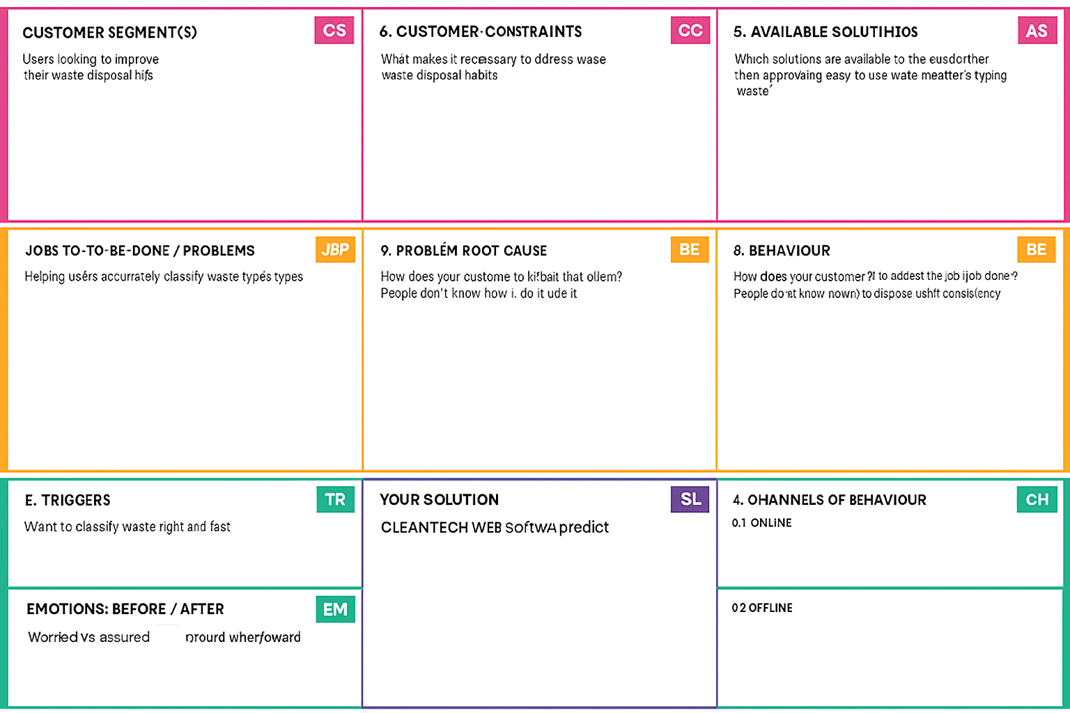

## 4.2 Proposed Solution

|  |  |  |
| --- | --- | --- |
| **S.No.** | **Parameter** | **Description** |
|  | Problem Statement (Problem to be solved) | Improper segregation and management of solid waste results in increased environmental pollution and inefficiencies in recycling. Manual waste classification is time-consuming, inconsistent, and lacks scalability. |
|  | Idea / Solution description | "CleanTech" is an AI-powered smart waste classification system that leverages **Transfer Learning** to automatically identify and classify different types of waste (e.g., plastic, organic, metal, e-waste) from images. Users upload images via a web interface, and the model predicts the waste category, helping automate segregation and optimize disposal/recycling processes. |
|  | Novelty / Uniqueness | Unlike traditional rule-based or sensor-based waste management systems, Cleantech applies **deep learning with transfer learning**, allowing the model to adapt with fewer images and achieve high accuracy even in diverse real-world conditions. The solution is low-cost, flexible, and easily deployable on mobile/web platforms. |
|  | Social Impact / Customer Satisfaction | The solution promotes sustainable living, reduces landfill accumulation, and enhances recycling rates. Municipal bodies, recycling companies, and the general public benefit through improved awareness, cleaner surroundings, and easier waste handling. |
|  | Business Model (Revenue Model) | The model can be monetized through:  - Licensing to municipalities and waste management companies  - Subscription-based mobile app for residential and corporate users  - API integration for smart bins and IoT devices in smart cities |
|  | Scalability of the Solution | The solution is highly scalable:  - Can be trained on regional datasets to adapt to different waste types  - Deployable across devices (mobile, kiosks, smart bins)  - Cloud-based architecture allows for continuous updates and expansion |

## Solution Architecture

This solution architecture diagram illustrates a real-time system where high-speed cameras capture images of waste and an AI model classifies each item. Based on this classification, robotic arms automatically sort the materials, drastically increasing recycling purity and operational efficiency.

Find the best tech solution to solve existing business problems.

* A user provides input to the system.
* Images are gathered as the raw data for the project.
* Image preprocessing is performed to clean and prepare the image data.
* The data is split into "Train Data" and "Test Data" sets.
* A Deep Learning (DL) Algorithm is trained using the "Train Data".
* The trained algorithm is evaluated for performance using the "Test Data".
* The final, trained "Model" is created from this process.
* The user interacts with the model through a User Interface (UI).

The model provides a "Prediction" back to the user via the UI

**Solution Architecture Diagram:**

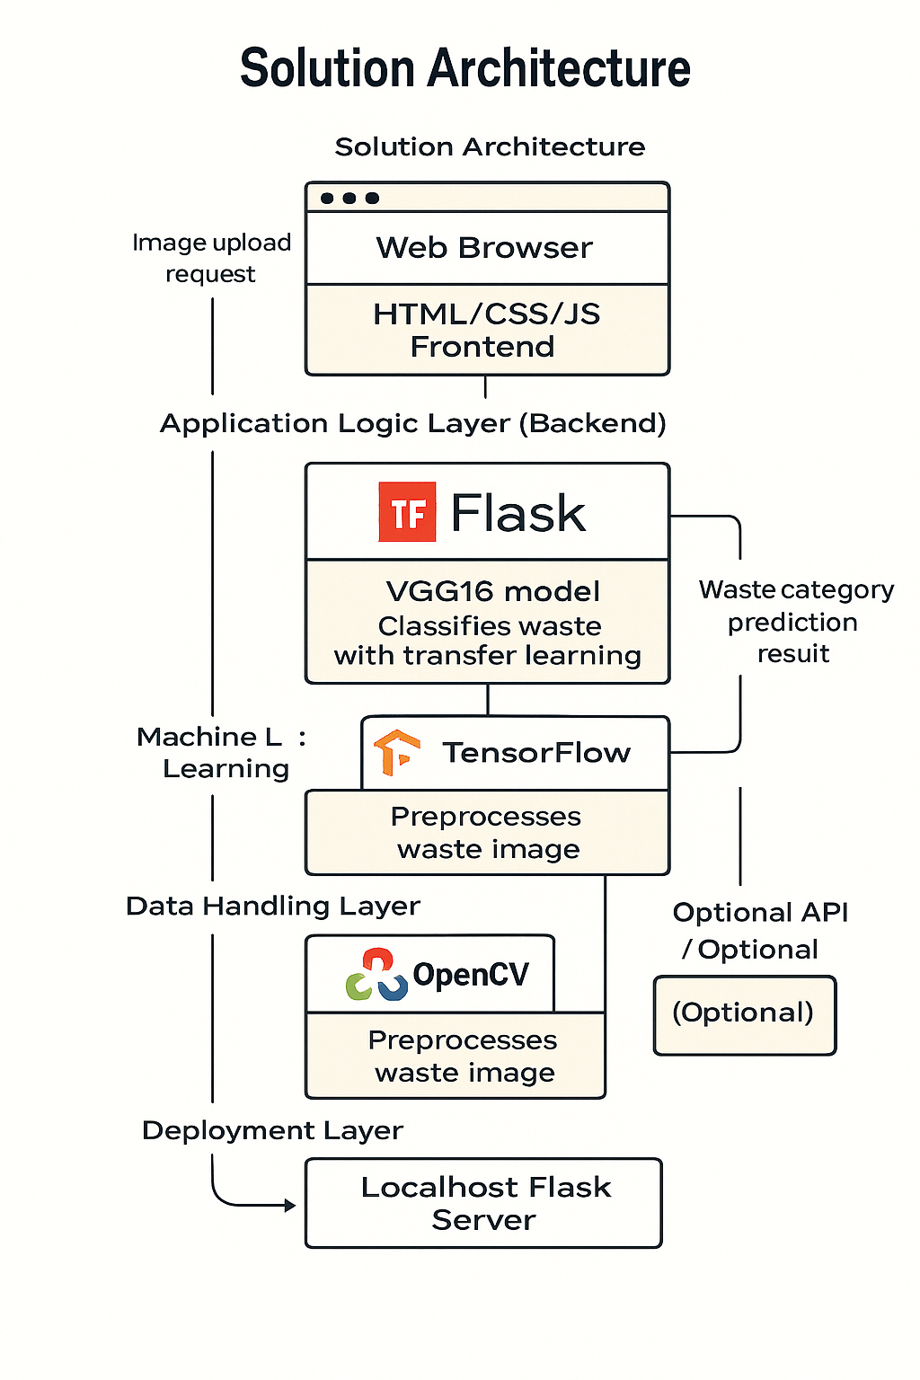

# 5. PROJECT PLANNING & SCHEDULING

## 5.1 Project Planning

The structured development of the Liver Cirrhosis Prediction System using agile methodology. The work was divided into sprints, with each sprint focusing on specific tasks like data preprocessing, model training, and evaluation. Story points were assigned to each task to estimate effort, and velocity was calculated to track team progress. This planning helped ensure timely, organized, and efficient project execution

**Product Backlog, Sprint Schedule, and Estimation**

| **Sprint** | **Functional Requirement (Epic)** | **User Story Number** | **User Story / Task** | **Story Points** | **Priority** | **Team Members** |
| --- | --- | --- | --- | --- | --- | --- |
| Sprint-1 | Image Upload & Preprocessing | USN-1 | As a user, I want to upload waste images and have them preprocessed automatically. | 6 | High |  |
| Sprint-1 | |  | | --- | |  |  |  | | --- | | Model Integration (VGG16) | | USN-2 | As a developer, I want to integrate VGG16 for waste classification | 8 | High |  |
| Sprint-1 | |  | | --- | |  |  |  | | --- | | Data Visualization (Frontend) | | USN-3 | As a user, I want to view classification results in a simple interface | 6 | Medium |  |
| Sprint-2 | Accuracy Testing & Tuning | USN-4 | As a developer, I want to evaluate the model for accuracy and improve it | 6 | High |  |
| Sprint-2 | |  | | --- | |  |  |  | | --- | | Results & Feedback Display | | USN-5 | As a user, I want to see results and provide feedback on predictions | 4 | Medium |  |
| Sprint-2 | Report Export (PDF/CSV) | USN-6 | As a user, I want to download a formatted report (PDF/DOCX) of the results | 5 | Medium |  |
| Sprint-3 | GitHub Hosting & Documentation | USN-7 | As a team, we want to upload code and create GitHub documentation | 4 | High |  |

**Project Tracker, Velocity & Burndown Chart:**

| **Sprint** | **Total Story Points** | **Duration** | **Sprint Start Date** | **Sprint End Date (Planned)** | **Story Points Completed (as on Planned End Date)** | **Sprint Release Date (Actual)** |
| --- | --- | --- | --- | --- | --- | --- |
| Sprint-1 | 20 | 10 Days | 19 May 2025 | 28 May 2025 | 20 | 28 May 2025 |
| Sprint-2 | 15 | 10 Days | 29 May 2025 | 7 June 2025 | 14 | 7 June 2025 |
| Sprint-3 | 11 | 10 Days | 9 June 2025 | 18 June 2025 | 11 | 18 June 2025 |

**Velocity:**

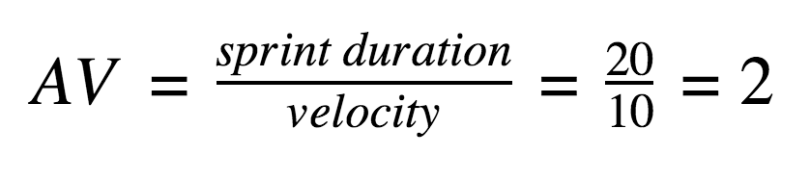

# 6. FUNCTIONAL AND PERFORMANCE TESTING

## 6.1 Performance Testing

The models were evaluated using accuracy, Confusion Matrix, Classification Report. VGG16 MODEL achieved the best performance.

|  |  |  |  |
| --- | --- | --- | --- |
| **S.No** | **Parameter** | **Values** | **Screenshot** |
|  | Metrics | **Classification Model: •** Final Training Accuracy: 82.0% • Final Validation Accuracy: 78.2% • Loss decreased consistently per epoch |  |
|  | Tune the Model | **VGG16 with Transfer Learning** • Tuned: learning rate, batch size, epochs • Validation done using train/test split (no cross-validation) |  |

# 7. RESULTS

## 7.1 Output Screenshots

This section presents visual evidence of the working prototype and results obtained from the CleanTech Waste Classification System. The screenshots demonstrate core system functionalities—from image upload through preprocessing to final waste type prediction. These visuals reflect how the system operates at each stage, showcasing its usability, prediction accuracy, and output clarity.

Web Interface Form:

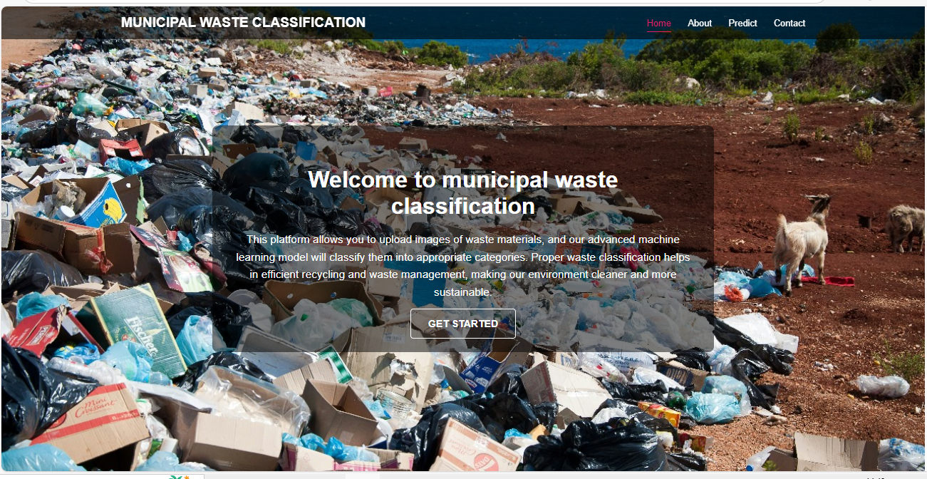

Prediction Report:

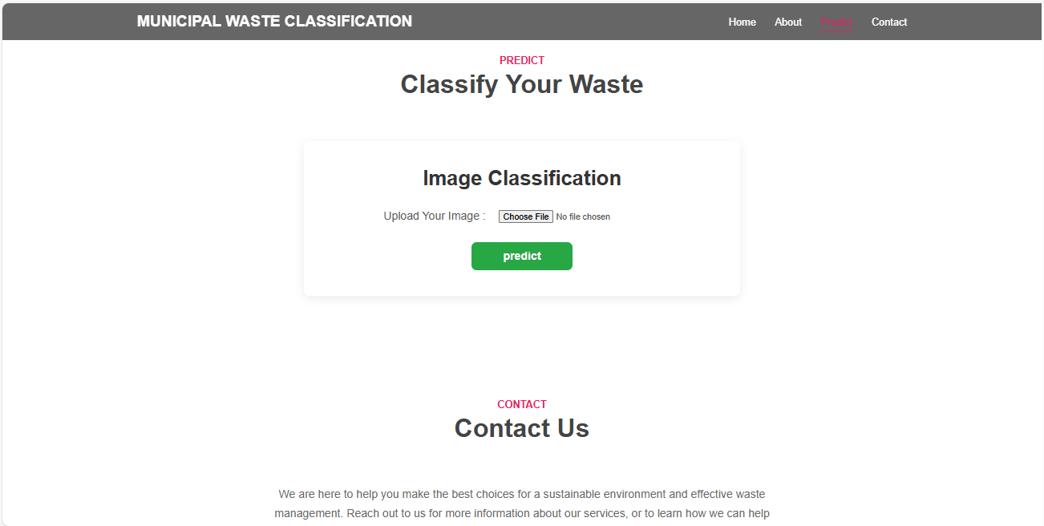

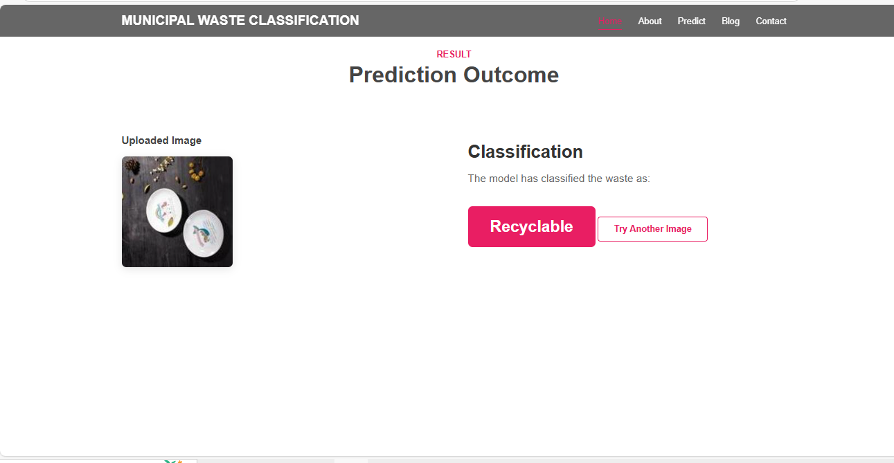

Accuracy of Models:

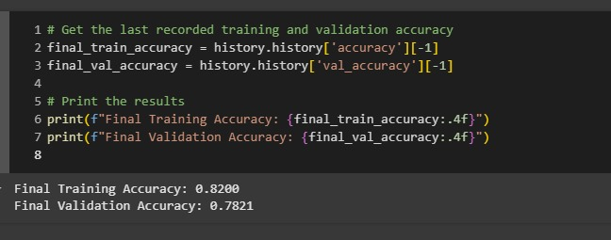

Model Evaluation Metrics Output:

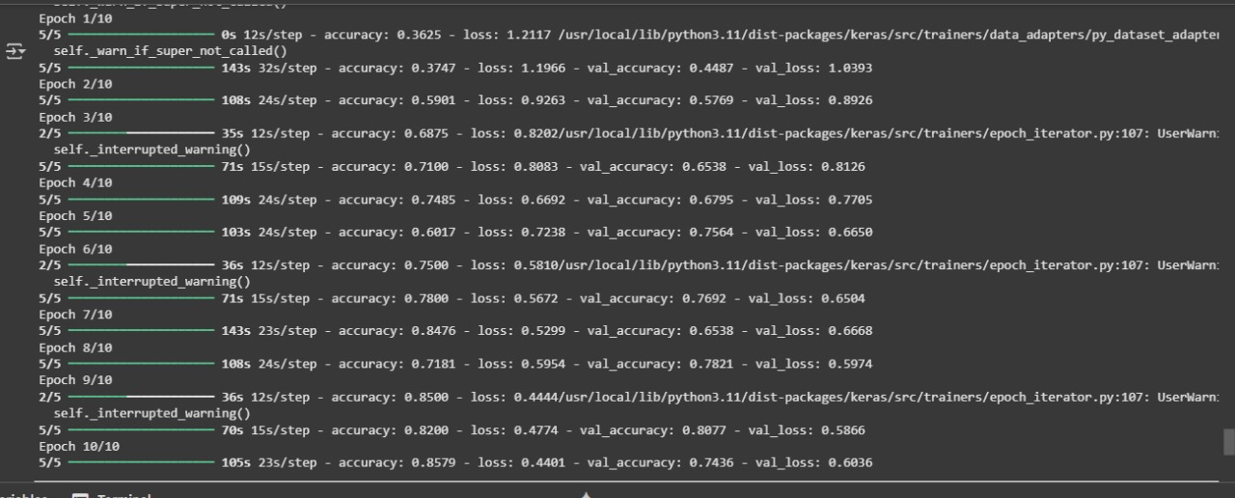

# 8. ADVANTAGES & DISADVANTAGES

**Advantages:**

* **Automated Waste Classification**: Uses a deep learning model (VGG16) to accurately identify waste types, reducing human error.
* **User-Friendly Interface:** Simple web-based interface (HTML/CSS/JS) allows anyone to upload images and view results easily.
* **Transfer Learning for Better Accuracy:** Leveraging pre-trained VGG16 boosts model performance, even with limited training data**.**
* **Supports Environmental Sustainability:** Encourages responsible waste disposal by helping users segregate waste correctly.
* **Offline & Lightweight Deployment:** Runs locally using Flask without the need for cloud resources or internet connectivity.
* **Modular and Scalable:** Codebase is modular and can be extended to include new waste categories or integrate into IoT bins.

**Disadvantages:**

* **Limited by Image Quality:** Poor lighting or unclear images can reduce prediction accuracy.
* **Model Bias from Training Data:** If the dataset lacks diversity, the model may perform poorly on unseen waste types.
* **No Real-Time Camera Integration:** Currently supports manual image upload only; does not process real-time video input.
* **Local-Only Access:** Not yet deployed online, which limits accessibility and scalability for larger communities**.**
* **No User Personalization:** The system treats all users equally—no tracking or feedback learning per user session.

# CONCLUSION

The **Clean Tech** project effectively showcases how **Transfer Learning** can be applied to automate waste classification, improving accuracy and reducing the need for manual segregation. By using AI to streamline the waste management process, it supports better recycling practices and environmental sustainability.

This scalable and cost-effective solution is adaptable to various regions and waste types. It aligns with global sustainability goals and demonstrates how modern technology can address real-world environmental challenges in a practical and impactful way. With a user-friendly interface and efficient model performance, the solution is well-suited for both public and private sector deployment. Clean Tech sets the foundation for future innovations in smart waste management and serves as a step toward cleaner, smarter, and greener cities.

The success of this project highlights the potential of AI in driving environmental change. By making waste classification simpler and more accessible, Clean Tech empowers communities and organizations to act sustainably. It also fosters technological awareness and civic responsibility. With continued support and enhancement, this solution can evolve into a vital tool in the global fight against waste mismanagement.

# 10. FUTURE SCOPE

* Real-Time Deployment with IoT Smart Bins: Integrating the model with smart dustbins equipped with cameras to perform real-time classification and segregation.
* Expansion to More Waste Categories: Enhancing the dataset to include more specialized waste types (e.g., biomedical, electronic waste).
* Mobile App Development: Creating a mobile application to allow households to scan and identify waste at home with instant feedback and sorting suggestions.
* Multilingual & Voice-enabled Assistance: Adding support for regional languages and voice-based instructions to increase usability across diverse populations.
* Integration with Government Recycling Programs: Collaborating with municipal bodies to deploy the model in urban waste management systems and public disposal units.
* Continuous Model Training with Feedback Loop: Using user feedback and misclassified images to retrain and improve model performance continuously.

# 11. APPENDIX

Source Code: <https://github.com/Rajeswaril4/cleanTech_Transforming-_Waste-_Management-_with-_Transfer-_Learning/tree/main>

Dataset Link: [Municipal Solid Waste Dataset](https://www.kaggle.com/datasets/elinachen717/municipal-solid-waste-dataset)

GitHub & Project Demo Link: <https://github.com/Rajeswaril4/cleanTech_Transforming-_Waste-_Management-_with-_Transfer-_Learning/tree/main> & https://drive.google.com/file/d/1O9IebVCkbqQY9jWw_gxsf2AwhNdlFyrT/view?usp=drivesdk